Assignment 2: Review of Bailey Kulman & Co’s eText

SENG310 Cognitive Walkthrough  
  
Kyle Wilson – V00897204  
Kenil Shah – V00903842  
Jacob Thom – V00892893  
Kelly Hamilton – V00869519  
Spencer Hart – V00895336

## Part 1

**Low Fidelity Prototypes**

While reviewing the other team’s assignment, we noticed some issues with their design. In the low fidelity prototype included with their plan, their systems expert routinely mentioned buttons that do not exist in that iteration. Having had the buttons exist would have significantly improved the walkthrough experience. The same can be said for including captions for each individual prototype.

Many of the prototypes lack linking elements or a way to tell prototypes apart from one another. An improvement would be to include button highlights or arrows pointing to related prototype slides. This would make the progression through the prototype easier to follow and understand.

Figure 1: Example of a linking element between prototypes

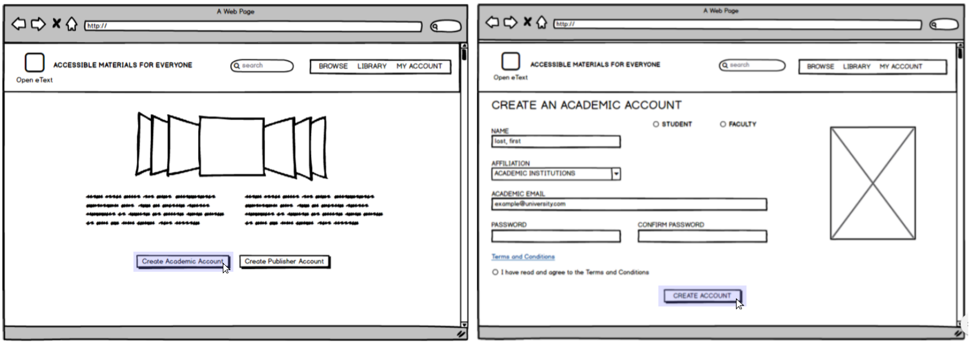

Uploading is important for the eText model, however when looking in the prototypes, there is no clear way to navigate to the upload page. The action sequence describes “Navigat[ing] to My Library page with the link in top right”, except no “My Library” link exists. Instead there is a search button, a library button, and an account button. This makes it unclear which link leads to the correct page.

Another miscellaneous issue is that the “My Library” page is unclear on whether or not it's only for storing books the user has uploaded, or if favorited books, and those downloaded are included as well. As most people using the service will not be uploading books, it is important to give this page other functionality.

**Action Sequences**

Actions sequences lack consistency with the prototypes shown. There are references to missing pages that are both noted (like the login page) and not noted (like the improperly titled “library” or “my library” page). There is also a lack of descriptivity in the action sequences when referring to certain key elements. Does the user need to have an account to browse textbooks? How does a user “select desired text” (i.e. through a link or is the whole search item clickable)? There is no clear purpose for the “my library” page since there is no related action sequence other than to upload a pdf.

To help streamline the uploading process, the upload button should be visible at all times after initial login; however, it is only available after creating an account. To avoid confusion, “Upload a PDF” should be labeled as “Upload a Textbook.” The page should also be able to upload multiple data types including EPub.

Another key feature that should be included is a high level description for each action. This lets someone reading the evaluation know the exact reason why a user is going to use each feature of the prototype. While the evaluation contains elements of high level descriptions, a more clear focus on the subject would help significantly.

**Things Done Well**

Their writings were clear and easily understandable. They had a clear and understandable vision for what they were trying to achieve and do. While much of what is described above sounds quite negative, the effort they put in to make this prototype is obvious.

## Part 2

Did the originating team supply necessary and sufficient artifacts (including Persona, Scenarios, the System Prototype itself)?

* 4 Marks. While the team provided a decent amount of supplies, some of those supplies lacked a few key elements. For the balsamiq prototype, several buttons were missing, that are referred to in the action sequences later on. This could have been improved when the team drafted their action sequences; instead of noting the missing details, the team could have added them to their submission.

Was the guidance clear?

* 2 Marks. Guidance is unclear when viewing the provided prototypes. Scrolling through forces the viewer to study what they are seeing and formulating how they may have reached that page. Guidance could have been improved with captions.

Was the guidance sufficient?

* 3 Marks. While there is a decent amount of guidance found within their evaluation plan, it feels like many of the ideas don’t link together. Guidance did not appear sufficient and required studying to follow in a logical manner.

Did the guidance specify a clear happy path (task with set of accompanying actions) for the user to follow?

* 4 Marks.Clear happy paths are noted and can be understood when viewing the action sequences. Although two seperate happy paths are viewable through the prototypes provided, the navigational difference between the two is not tangible.

Did the guidance provide one or more sad paths to indicate what a user might do?

* No, the other team’s walkthrough did not provide any “sad paths” to indicate what a user might do in such a scenario

What specific aspects of the delivery were appreciated or valued by your evaluating team?

* Our team reviewed the clear medium fidelity prototype. Effort was clearly put into its design to make the prototype appear genuine.

Which areas represent room for improvement, and how specifically could the originating team have made the evaluation proceed more smoothly?

* The connection found between the separate elements would be a great place to start. While there is a sufficient number of actions, those actions feel disconnected. An idea for improvement would be to include a few key prototypes that include all elements found in the action sequences.

Additional comments you wish to share

The team we were reviewing did not provide us with a rubric. We used our own to evaluate their project.